Chapter 5
Fungal Taxonomy and Systematics

Taxonomy and systematics refer to the naming and relative relationship of any biological organism. Here we discuss how fungi are classified, named and, more importantly, how this system is changing and can be a source of confusion for the non-academic, farming community. This information will prove useful if trying to protect crops against particular pathogens and also for determining how closely one fungus is related to another. In particular, when trying to find a treatment (biological, chemical, or environmental) to reduce pathogen infection of a Cannabis crop.
Science has attempted to classify organisms in a hierarchical way, in order to help organize and make sense of nature. All extant organisms on earth that we know of have descended from a common ancestor, known as the last universal common ancestor (LUCA). Scientific systematics reflects the relation of organisms to other groups through this classification system. We can use this classification system to tell us some similarities and relatedness of fungi to other organisms in general terms.
The hierarchical classification follows the same arrangement for all living organisms. This classification begins with the most broad groupings of relatives, and gets more and more specific with every step of the way. As such, all organisms are sorted into one of three domains, then into clades, followed by kingdom, phylum, class, order, family, genus and, finally, species. Together, we may compile all of this information to create a ‘tree of life’ which helps us visualize the relatedness of all organisms. This tree contains all life on earth, from single-celled bacteria all the way up to the most evolutionarily derived organisms, including ourselves -Homo sapiens (Fig. 5.1).

Table 5.1. Hierarchical classification of some commonly encountered fungi
Kingdom | Fungi | Fungi | Fungi | Fungi | Fungi
Phylum | Basidiomycota | Mucoromycota | Mucoromycota | Ascomycota | Ascomycota
Subphylum |  | Glomeromycotina | Mucoromycotina
Class | Hymenomycetes | Glomeromycetes | Incertae sedis | Sordariomycetes | Leotiomycetes
Order | Agaricales | Glomerales | Incertae sedis | Hypocreales | Helotiales
Family | Agaricaceae | Glomeraceae | Incertae sedis | Hypocreaceae | Sclerotiniaceae
Genus | Agaricus | Glomus | Planticonsortium | Trichoderma | Botrytis
Species | Agaricus bisporus | Glomus  mosseae | tenue  mosseae | Trichoderma  viride | Botrytis  cinerea
Common Name | portabello, crimini, button mushroom | arbuscular mycorrhiza,  endomycorrhiza | Mycormycotina fine root endophytes | Green mold | Grey mold, bud rot

Classification has generally been rooted in a concept of the ‘vertical’ transmission of heritable traits from parent to offspring, with lineages diverging over time as evolution imposes separations among populations of living beings. However, genes do not only move from parent to offspring. Genes may also move sideways during an individual's lifetime, or ‘horizontally’, and do not necessarily originate from a relative or even member of their own species. The result is a tree of life that has many fused branches which depart and recombine over time. For this reason, some modern biologists eschew the tree analogy for something more akin to a web (Doolittle, 2000). Horizontal gene transfer is particularly common at the ‘base’ of the tree among the prokaryotes.
Some scientists estimate that there may be somewhere around 5 million species of fungi in the world, about 70,000 of which have been described (Blackwell, 2011). Regardless of how many species of fungi there are, what we do know is that fungi are a very diverse group of organisms that are ubiquitous in nature. We still have much to learn about this fascinating Kingdom.
As we begin to attempt to identify different types of fungi, it is important to keep in mind what makes all fungi similar and also what makes a button mushroom different, from say, a morel mushroom. Macroscopically there are some clear differences. However, with the help of a microscope, there are features that easily separate out many of the various phyla of fungi. This will help out immensely when attempting to identify moldy fungi. Some fungi obscure their true identity from observers attempting to utilize physical features alone and require genetic study to differentiate.
The scientific names of species, known as their specific epithet, consists of the two most restricted levels of the categorical titles mentioned: genus and species. This naming system is referred to as binomial nomenclature and was pioneered by Carl Linnaeus; the same person who pioneered the hierarchical classification system. Linnaeus, working a century before the Theory of Evolution was to be elegantly described by Charles Darwin and Alfred Russel Wallace, was of the contemporary opinion that species were immutable and unchanging from their original creation. Therefore, Linnaeus's classification system was a taxonomy, concerned only with the naming of organisms, while grouping together those that appeared similar for ease of categorization.
Modern taxonomy now incorporates the Theory of Evolution to include not just diagnostic features of species phenotypic expressions, but also the relatedness of species, or its phylogeny, through time. This synthesis of taxonomy and evolutionary relatedness has resulted in the field of systematics.

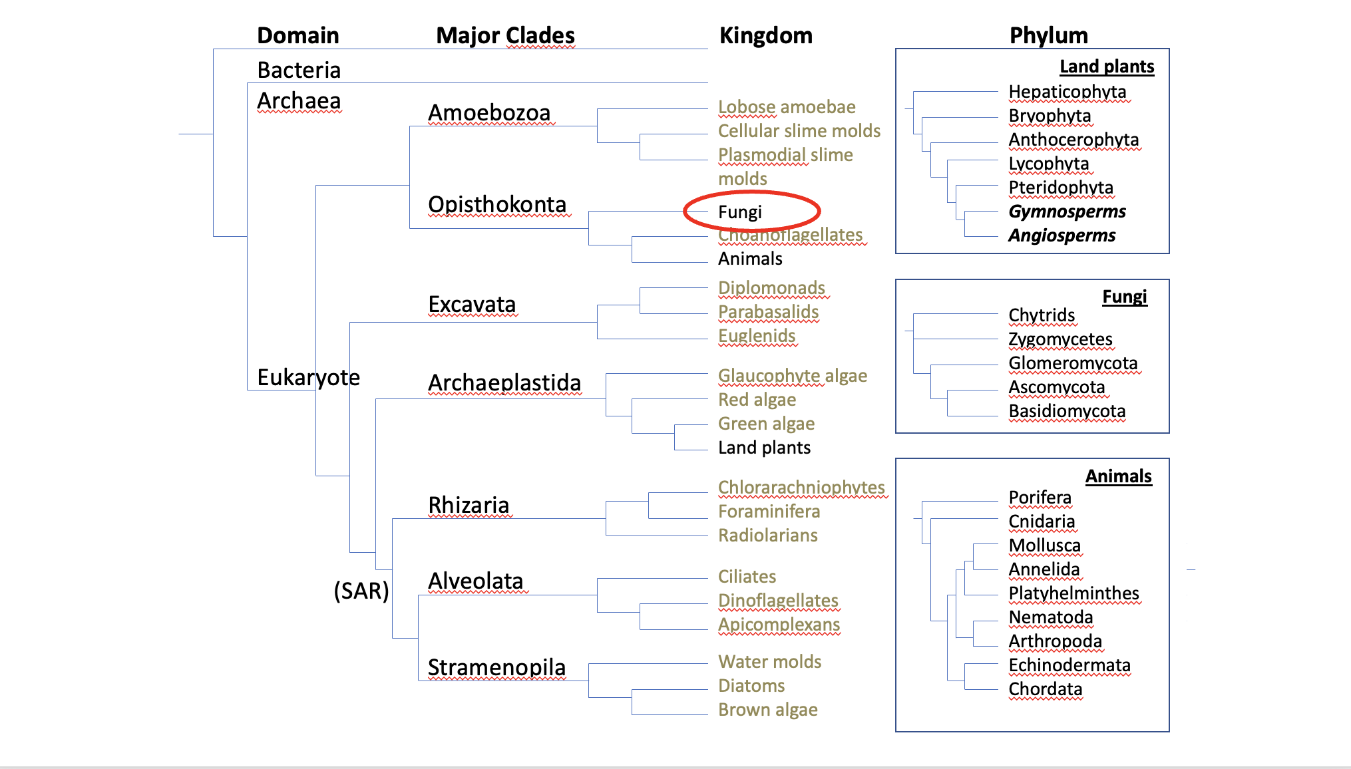

Figure 5.1. Example of a basic tree of life.

Depending on which classification scheme you read, there are 5-18 phyla in the Kingdom fungi. For our discussions, these include Basidiomycota, the club fungi; Ascomycota, the sac fungi; Mucoromycota (formerly ‘Glomeromycota’ and ‘Zygomycota’); Chytridiomycota, the mobile ‘little pot’ fungi; and finally the Microsporidia, unicellular parasites formerly thought to be non-fungi protists. The ‘Zygomycota’ have been discovered to be a polyphyletic grouping (not descended from an immediate common ancestor) and is no longer formally recognized as a phylum (Hibbet et al 2007, Spatafora 2016, Tedersoo et al. 2018). The term is still in popular usage and will serve as a useful grouping in this book. Similarly, ‘Glomeromycota’ was the former name of the Glomeromycotina, a subphylum in Mucoromycota (Bruns et al. 2017).
Ascomycota is home to many soil decomposers, ectomycorrhizal species, most plant endophytic fungi, as well as most of the dreaded plant and human fungal pathogens. Basidiomycota contains most of the species people recognize as ‘mushrooms;’ they often are responsible for primary decomposition of woody materials, though many form ectomycorrhizae with woody plant species and some species cause plant and human disease. The Mycoromycota comprise the arbuscular mycorrhizal fungi in the Glomeromycotina, in addition to the ‘Zygomycota’ fungi such as bread molds, post-harvest strawberry mold, as well as the newly transcribed Mucoromycotina Fine Root Endophyte mycorrhizae (Orchard et al 2016). Chytridiomycota (as well as bacteria and archaea) also assist in the breakdown of cellulolytic, lignin, chitin, and keratin based materials.
Although people have been studying and attempting to classify fungi for hundreds of years, fungal systematics is in a state of constant flux. Scientists and researchers frequently go back and forth on where certain fungal organisms belong on the tree of life. With the advancement of various molecular techniques, we are able to better estimate the relatedness of different fungi. However, molecular techniques themselves develop over time as our understanding increases, as does our understanding of how to interpret the resulting data. It is important to remember that these classification systems are our best current understanding of these organisms’ relatedness in nature. Current classifications are not sacrosanct. The names of species and our understanding of their placement on the tangled tree of life still change frequently.
With that in mind, we must accept that some fungi that we now know by certain names may be given a new name in the upcoming years. The result of these frequent name changes is that technically-defunct names for fungi may remain in circulation as synonyms, particularly for fungi that were widely known by names based on old taxonomic classifications. A prime example is the endomycorrhizal fungus Rhizophagus irregularis. Two decades after its official name change, this agriculturally-important fungus is still widely marketed under its defunct, but more popularly recognized name, Glomus intraradices. Keep this in mind as you learn fungal species names (see Index Fungorum at indexfungorum.org for up to date scientific names and listings of previous synonyms).
The two phyla to which all mushroom-producing fungi belong are the Basidiomycota and Ascomycota. In Basidiomycota, spores are borne-exterior, on a club-shaped structure called a basidium, typically in groups of four, whereas in Ascomycota, spores are developed inside a sac-like structure called an ascus, typically in groups of eight spores. Throughout our journey with mycology, we will see time and time again the spores and spore-bearing structures will aid in identification.
Fungal phyla:
Basidiomycota: These fungi, which include many mushrooms, mostly act as decomposers, breaking down organic material like crop residues and wood. While they’re not huge plant pathogens, some species can affect Cannabis, such as Rhizoctonia (which causes damping off and other root diseases) and Aecidium cannabis (a rust fungus). Basidiomycota have specialized structures called basidia which produce spores, often seen on the gills or pores of mushrooms.
Ascomycota: This group includes molds like Trichoderma, Aspergillus, and Penicillium. They’re commonly found in soils with organic matter. These fungi typically reproduce via spores inside special sacs and can live in different environments, including as symbionts, decomposers, or pathogens. They’re often unnoticed because many reproduce asexually.
Glomeromycotina: These fungi form symbiotic relationships with plants, including Cannabis, by attaching to their roots. They create structures that help plants absorb nutrients (like phosphorus) and water, while the plant provides them with sugars. This relationship is particularly helpful in nutrient-poor soils. These fungi reproduce via spores, and while their sexual reproduction isn’t well documented, they might have some form of it.
Mucoromycota & Zoopagomycota: Formerly grouped as Zygomycota, these fungi have been split into two groups. Mucoromycota are mainly soil saprophytes and occasionally pathogens (like the mold on bread). They can form symbiotic relationships with plants but also cause issues for crops like strawberries. Zoopagomycota are mostly parasitic, attacking insects. Some members are used as natural pest control. These fungi reproduce via specialized structures and can even self-fertilize in some cases.
Chytridiomycota: These aquatic fungi are some of the most ancient, and they have the unique ability to swim using flagellated spores. While most chytrids affect small organisms like algae or amphibians, some plant diseases, like potato wart, are caused by them. They’re generally more useful as decomposers and help break down tough materials like chitin. Some chytrid species have even been found on Cannabis, though we don’t fully understand their role yet.
In general, these fungi play important roles in nutrient cycling, plant health, and sometimes crop diseases. Their interactions with Cannabis are still being studied, so there may be more to discover.
‘Deuteromycota’
The ‘Deuteromycota’ are an artificial grouping of filamentous fungi that exist in the asexual (anamorphic) state. This superficial grouping is useful for characterizing these organisms based on form and function. Prior to the invention of molecular techniques, fungi were primarily classified based on their sexual structures. However, since certain fungi did not produce sexual reproductive structures in vitro , scientists were unsure which group to place these organisms in. Therefore, mycologists created a new group for the ‘imperfect fungi’ named deuteromycota.
Most of these species are Ascomycota, though Zygomycota and Basidiomycota also may be classified as ‘Deuteromycetes.’ Many of these fungi cause disease in animals and plants, therefore creating a giant economic impact.
Again, this classification scheme is based solely on morphological features and mainly the lack of reproductive structures. Therefore this grouping does not indicate the true genetic relatedness of these fungi but is still useful for relaying information about the organism's physical features. Many mycologists still use this classification method out of ‘convenience and tradition’ (Volk 2013).
The non-fungi:
Oomycota: Even though they’re called “water molds,” these organisms aren’t actually fungi. They belong to a completely different group called Heterokonts, and they’re more closely related to algae (like kelp) than to fungi. Oomycota have filamentous structures similar to fungal hyphae, but their cells don’t have septa. They reproduce with mobile spores (zoospores) and resting spores (oospores). Some species, like Pythium, are a problem for Cannabis farming, causing damping off in seedlings. However, some oomycetes, like Pythium oligandrum, are beneficial because they can act as biocontrol agents, fighting off harmful soil pathogens like Rhizoctonia and Botrytis.
Actinobacteria: These are gram-positive bacteria that form filamentous networks, which makes them look a bit like fungi. However, they’re not fungi at all—they’re prokaryotes. These bacteria can decompose organic matter, fix nitrogen, and thrive in low-oxygen environments. A well-known example is Streptomyces, which produces antibiotics and is important in agriculture. They’re often responsible for that earthy smell you get after rain in forests, and they can be found in hot compost piles. Even though they were once thought to be a "missing link" between fungi and bacteria due to their fungal-like growth, molecular research has proven they are distinct from fungi.
So, while oomycetes and actinobacteria may resemble fungi in some ways, they have their own unique roles and relationships in nature.
In summary:
- Taxonomy and classification is important to show how related different organisms are to each other
- Fungi are eukaryotic organisms closer related to animals than to plants
- 5 major phyla in kingdom fungi are Basisiomycota, Ascomycota, Glomeromycota, Zygomycota, and Chytridiomycota
- Fungal taxonomy is in a state of constant flux
- Water molds and slime molds are not true fungi

